Note: Include this page only when adding / amending / deleting a document. If using this document as a record, this Revision History page can be omitted.

REVISION HISTORY

Revision no | Date | Description of Changes | Reason for Revision | Revised by | Approved by
2 | 10 May 13 | Add revision history page  Simplified the procedure since Employee Devt training is already incorporated | - Recommendation from Stage 2 audit | RDPlacido  LDLacuna
3 | 01 May 14 | - Re-include in the list of references the guidelines on matrix preparation, administration and review |  | LDLacuna
4 | 8 Apr 16 | Added disclaimer when printing the document | For document control | RCGanal | MVBergantin
TM-BR-MG- 11 Rev02, 10302015

I. Objective
To assess the competency level of each employee and identify what soft and hard skills trainings are need based on the results of the employee competency matrix report.
II. Scope
This procedure defines the action and responsibilities of the HR Head, Training Head, Unit Heads and Account Managers in the competency assessment and development plan. This plan will only apply to regular employees. This covers activities from the receipt of the accomplished Employee Competency Matrices to the updating of the records.
III. Definition of Terms
Employee Competency Matrix | - Is a document filled-out by the Unit Head where the his competency level of the employee based on his knowledge, skills and attitude is being assessed.  - Identifies what trainings are needed in order to increase the competency of the employee and reach what is required for the position level.
Employee Competency Matrix Report | - It reports the recommended training for the employees.  - Target schedule will be placed once the training calendar is already finalized.  - Status whether the employee has attended or not the training will also be reflected.

- Procedure Details
RESPONSIBLE | ACTIVITY | INTERFACE
HR Head  Training Head HR Head  HR Head | 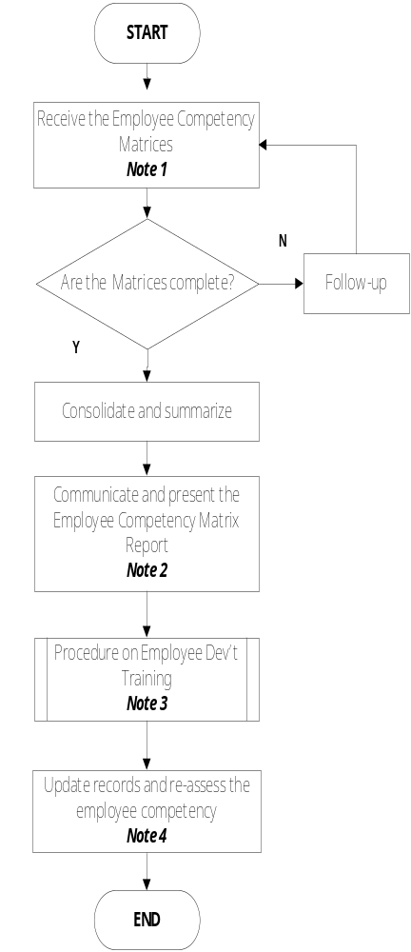 | Employee Competency Matrices Unit Heads / Clients  Employee Competency Matrix Report ManCom  Procedure on Employee Dev’t Training  Guidelines on Identification of Training Participants  Updated Employee Training History Tracker and Training History Card  Unit Heads

Notes:
- HR Head disseminates the matrices every first Friday of September and expects to receive the accomplished matrices after one month.
- Employee Competency Matrix Report is submitted to ManCom every last Friday of October.
- HR Head will also identify the participants in the training especially those who are deployed at the client site. The list will be coordinated with the Training Head.
- Re-assessment of the competency level of the employee using the matrices will be done during the set schedule.

- References
- Employee Competency Matrix
- Procedure on Employee Development Training
- Guidelines on Identification of Training Participants
- Guidelines on Matrix Preparation, Administration and Review
- Training History Card

- Quality Records
- Accomplished Employee Competency Matrices
- Employee Competency Matrix Report
- Employee Training History Tracker
- Updated Training History Card
- 201 File

